Dear Friends,
It was with a sense of excitement and anticipation that, a few years ago, we left the hotel early in the morning to go and visit the north western shore of Lake Galilee in Tabgha, Israel. We wanted to arrive before the crowds and visit the place where it is thought that the risen Jesus may have appeared a third time to his disciples.
We were not to be disappointed for it was a beautiful and tranquil spot where as a group we took our sandals off and paddled in the warm water with small fish darting between our toes as we imagined Jesus standing on the beach calling out to his disciples.
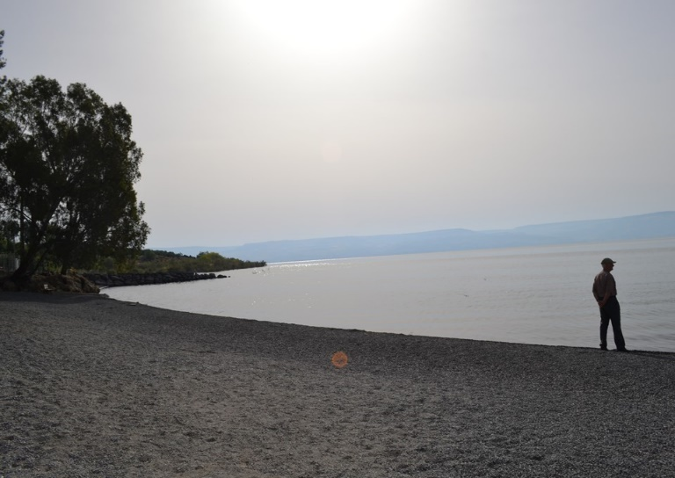
Returning to Galilee the disciples had gone fishing but had caught nothing all night. Early in the morning, Jesus stood on the shore, but the disciples did not realise it was him.
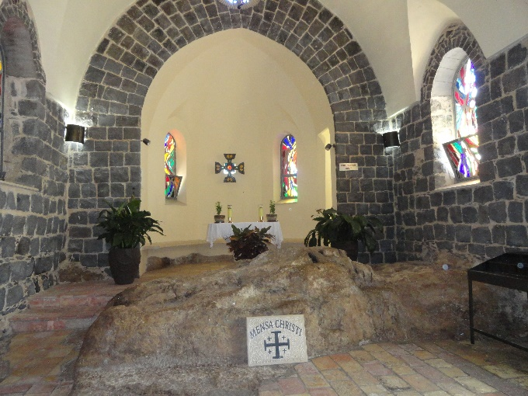
No doubt with a twinkle in his eye he called out to them ‘Friends, haven’t you any fish?’ ‘No’ they shouted back.
‘Throw your net on the right side of the boat and you will find some.’
When they did, they were unable to haul the net in because of the large number of fish.
Then one disciple said to Peter ‘It is the Lord!’ and Peter wrapped his outer garment around him and jumped into the water, so excited to see him again. As the sun rose over the waters together the disciples shared breakfast on the beach. None of them dared ask him ‘who are you?’ because they knew it was the Lord. (John 21).
I love the fact that time and time again Jesus wanted to reassure his disciples that he was raised. He understands our human nature that so easily doubts, questions and wonders if what we have come to believe, and experience is really true. In different ways, to Thomas in the upper room, the two disciples on the Emmaus Road and now by the shores of Galilee he meets with his friends and constantly offers gentle reassurance.
Maybe after all the difficulties and uncertainty of the last year, maybe through not being able to meet together in worship, maybe feeling at times isolated we too need to be reassured of the risen presence of the Lord who is always with us.
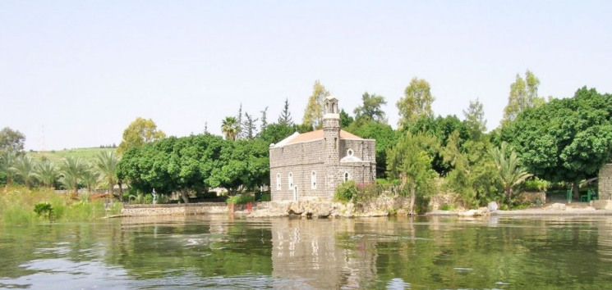
Just off the beach is ‘The Church of Peter’s Primacy’. Its initial structure was first laid in the 4th century to stand as a sacred reminder of the conversation Jesus was to have with Peter after they had shared breakfast together. It was lovely just to go in and be still in this holy place.

Jesus went on to minister to Peter following his denial in the courtyard before the events of the cross and ask him ‘Do you love me?’ A moving account where despite his failings Jesus still invites Peter to ‘Follow me’ and subsequently lead his people (Feed my sheep’).
How reassuring to know that whatever our doubts or failings God doesn’t give up on us, still invites us to follow and calls us to use our gifts to build his church.
The Duke of Edinburgh
Following the death of Prince Philip last week at the age of 99 years we remember the Royal Family this weekend as they share in the funeral service at St George’s Chapel, Windsor at 3pm this Saturday.
Prince Charles said over the last 70 years his father had "given the most remarkable, devoted service to the Queen, to my family and to the country, but also to the whole of the Commonwealth".
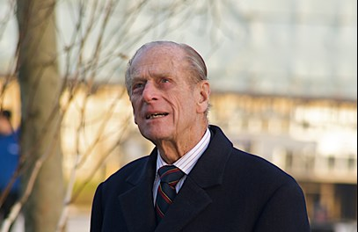
A prayer is offered by the Methodist Church as is follows:
Lord God
We give thanks for the long life of Prince Philip, for all that he has contributed to our nation and beyond, and for his support of our Queen. We pray that he will be at rest trusting in the grace of God. We remember before you Her Majesty the Queen and her family praying that they will know your comfort and strength in the days to come. In Jesus' name, Amen.
The President and Vice-President of the Conference

Church News Update
Please continue to pray for Rev. Chris Blake and his wife Joy - our Superintendent Minister who after initial surgery on his eye 3 weeks ago requires a second operation (Fri 16th April) followed by 2 weeks of posturing face downwards for every 50mins/hour.
We also remember others within our various church families who have suffered ill health and are being supported by family and friends.
Boys & Girls Brigade
With the easing of restrictions and following ongoing guidance we are delighted that Boys Brigade and Girls Brigade will be resuming their activities at Alton in the coming month. Please pray for the children and their leaders as they plan their future programmes.
Easter Day
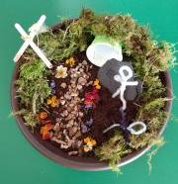
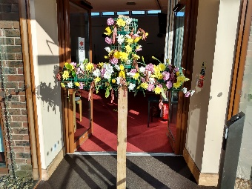
It was lovely to share in a ‘live’ Easter Day service at Alton, standing and waving palm crosses to the Easter hymns, adding flowers to the cross and standing it out in the sunshine afterwards and Emma, Noah and Anna making Easter Gardens.
Worship Service
The On-Line Service this week is led by Liz George via www.altonmethodist.org.uk
Pause for Thought appears on the same church web site on a Wednesday each week.
It is hoped that regular ‘live services’ will be able to resume in all our churches after step 3 of the roadmap out of lockdown towards the end of May.
Every blessing, Philip.
philip.simpkins@methodist.org.uk

