Dear Friends,
Last week the Methodist Connexional Magazine dropped through my letterbox. It had the heading ‘Love this Calling’ and was full of inspirational stories of people who had felt called to service through their Christian faith.
A young mum from Burniston Methodist Church, Scarborough spoke about the calling to love your neighbour. Laura had worked with Zambian women experiencing gender-based violence, she had given her student loan to a family in Romania whose house had washed away, and she had travelled to Mexico with her family to help on a building project.
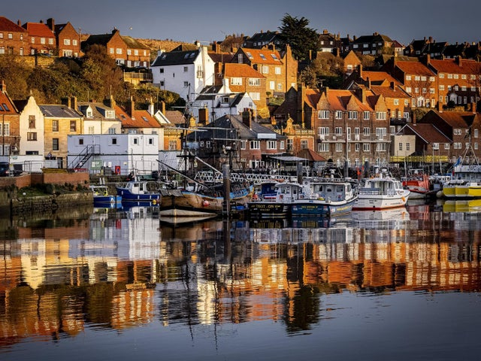Scarborough
Laura also felt passionate about helping people on her own doorstep saying:
Where there is need, I do what I can to meet it, whether its here in Scarborough where I live, or in Zambia where the richness of the land is being plundered by other countries.
I give what’s needed whether that’s a bunch of flowers to a neighbour, or a roof box full of clothes to refugees in Calais.
When asked what she might say to people who might say ‘I could never go overseas and do what you do’ she replied:
‘We are all better together – some people have time, some financial resources, some have wisdom, and some a smile for others. The key thing is to care for humanity, not to give to make ourselves better.’
We all have a calling to recognise people as equal to ourselves and loved by God. We need to give as we’d want to receive.’
A powerful and challenging testimony fitting for this week’s lectionary readings where the Apostle John says, ‘Dear Friends, let us love one another, for love comes from God.’ (1 John 4.7)
Others within the Connexional Magazine talk about their own sense of calling to a variety of works of service.
There is Alan, director of a healthcare provider that is administering thousands of Covid-19 vaccinations to the most vulnerable. He speaks about God opening and closing doors, leading him to where he is today. As a business leader he writes:
It is not my skills in the boardroom, or my skills as a business leader, or my skills on a computer that distinguish me as a Christian. Rather it is how I go about these tasks, and the core beliefs that give me my foundation.
God calls us to be disciples throughout our lives. Not just when we are with our church family – but also when we are with our human family, and with those people that we spend our days with, in whatever situation that may be.
Reading on through the magazine I come across those called to be a workplace chaplain to agriculture, another person with a vocation to come alongside those struggling with mental health, and others responding to their calling to become Local Preachers.
Michaela Barker writes:
I hear it from others – from great prophets in the bible to other preachers – God was calling them to ministry, and they did their best to ignore it. I am no different. I ignored my calling for so long. Throughout my life God was calling me, but I kept finding excuses not to answer.’
Eventually I was in what might be termed a metaphorical ‘Elijah’s cave’ where I began to hear God as the still, calm voice; and this time I knew I had to respond.’
As we begin to emerge from lockdown, church begins to reopen, I wonder in what way God is calling you and I to serve him?
Maybe it will be to take up what you have always done, or maybe it will be to step out and do something new.
‘Vocation is the place where your deep gladness meets the world’s deep need.’ Frederick Buechner.
Like others before us and around us let us listen out for God’s leading and direction.
Did I hear your voice
in the beat of a butterfly’s wing,
the melody in a blackbird’s song?
Did I feel your presence
in the warmth of a summer breeze,
the coolness of a mountain stream?
Did I sense your touch
in the smile on a young child’s face,
the shoulder I can lean upon?
You speak to us
in many ways.
Reveal yourself
in many ways
if our ears can hear,
our heart can feel,
our mind can know,
and our hands are open
to your touch.
Aldershot Church News Update
We have received a request from the army chaplain to 27 RLC, based in Travers Barracks, Aldershot. They are gathering supplies to support the aid effort because of the volcanic eruptions on St Vincent. They have a number of soldiers in the regiment from St Vincent and are able to send out supplies for free. If you are able to donate any items from the list below, they will be pleased to receive them at the Royal Garrison Church (on the hill next to the Wellington horse statue, Farnborough Road, GU11 1QA), Monday to Friday 8am - 3pm, or Sunday mornings.
Requested items:
Water, nappies, toiletries, sanitary products, tinned food, flour, rice, sugar, pasta, pot noodles, squash drink, hand sanitiser, face masks, laundry detergent, tomato ketchup, bin liners, clothes, disposable cups and plates, baby food.

At Aldershot the Church AGM will be held via Zoom on Wednesday 5th May at 7.30pm.
We continue to pray for Rev Chris Blake and his wife Joy as the healing process continues following eye surgery. Rev Nick Oborski is the Acting Superintendent.
Worship Service
The On-Line Service this week is led by Mrs Jennie Marlow via www.altonmethodist.org.uk. We are planning for live services to return in our circuit churches from Sunday May 23rd.
Every blessing Rev. Philip Simpkins (covering for Rev Chris Blake)

The Connexion, Love this Calling, Methodist Church Spring 2021 & http://www.methodist.org.uk/theconnexion
Prayers on a Theme of Christian Calling (faithandworship.com)

