Dear Friends,
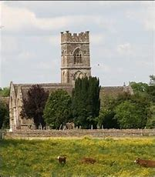
Long, long ago during my primary school days we used to walk from the village school down the lane to the Parish Church, set in a field in the village of Luckington, during the month of May.
The reason for this adventure (and excuse to miss lessons) was to celebrate Ascension Day which occurs 40 days after Easter (13th May 2021)
Memories of this returned when I was asked to join a Church of England School and walk with the children, complete with a picnic up country tracks to a place called ‘Kelston Tump’ from which you had a fantastic view over Bath. It was here that the teacher led the children in an outdoor assembly, and I was asked to give a short talk on the Ascension – a hidden helium balloon seemed to help as lots of pairs of eyes were left gazing up at the heavens, rather like the disciples!
He was taken up into heaven before their very eyes, and a cloud hid him from their sight. (Acts 1)
Early church writers demonstrate that Ascension Day has been celebrated by the church long before the 5th Century with St. Augustine saying that it was of Apostolic origin.
It is a wonderful, yet mysterious ‘God event’ that completed the earthly ministry of Jesus. It is as the risen ascended Lord that Jesus promised that he would then send his Holy Spirit upon the disciples, celebrated at Pentecost. It is as the ascended Lord that the bible says that Jesus prays for us (Hebrews 7.25) and that he reigns victorious, able to offer forgiveness and eternal life.

We sing the praise of Jesus,
Of our ascending Lord;
The triumph of our Saviour,
Of Christ the Son of God.
The forty days are over,
Earth sees his face no more;
But Christ the King of glory
We worship and adore.

Rejoice in Christ’s promise
We wait in prayer and praise,
The Spirit sent from heaven
To set the earth ablaze;
We pray with expectation,
We praise with one accord,
We wait for living fire
The power of the Lord
Norman Wallwork (b1946) StF 315
‘Thy Kingdom Come’
Through the leadership of the Archbishop of Canterbury Christians all around the world are invited to make the period between Ascension Day and Pentecost a special time to pray.
This reflects the period that the disciples waited and prayed for the Holy Spirit to come.
“In praying 'Thy Kingdom Come' we all commit to playing our part in the renewal of the nations and the transformation of communities." Archbishop Justin Welby
Why not consider how you might make a special time to pray for:
- Your friends and family
- Your church & its reopening
- Your community & its needs.
- Our world and the challenges it faces in places like India, Israel & Palestine and elsewhere.
In Alton - The Parish Church have several prayer events & walks that you are welcome to join as advertised on their website & newsletters.
In Aldershot -"Thy Kingdom Come” Prayer meetings, Aldershot will take place at 7.30pm on each evening from Ascension to Pentecost starting on 13th May and finishing on 23rd May 2021. These can be accessed on zoom and the joining details are the same for each meeting:
Meeting ID: 131 536 277
Passcode: Pray
You can also download the ‘Thy Kingdom Come’ Prayer App for daily updates and resources or visit https://www.thykingdomcome.global
Outreach and Christian Aid in Rowledge!
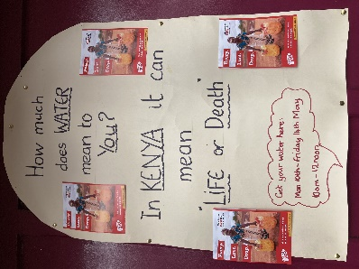
Rev David and Aileen Ashby have for some time creatively used their front garden & drive to hold an informal and socially distanced place for local people to stop for a chat and/or enjoy a coffee. Their situation next to the village shops has ensured that this has become quite a meeting place with lots of cheery ‘hello’s from passers by and a place ‘to sit a while’ for those who wish to.
During this last week they have used such an opportunity to support the work of Christian Aid in place of the usual ‘soup & roll lunch’ held at the church.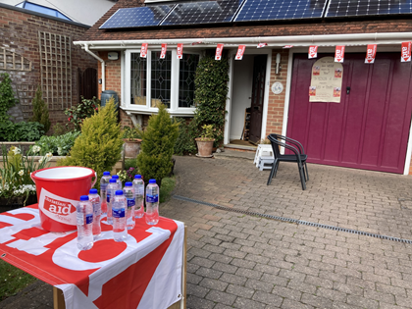
Thank you, David, Alieen… and Dee next door (also a member of Rowledge Methodist Church)
Alton Spring Walk
With spring flowers blooming and Covid restrictions easing, the first Alton church Seasonal Walk for more than a year is being planned. The Spring Saunter will take place on the morning of Tuesday 18th May. If you would like to come along, please contact David Allan on 01420 84739 or by e-mailing oldschoolhouse@gmx.co.uk to obtain the details of meeting time and place.
Worship Services
The On-Line Service this week is led by Rev Philip Simpkins via www.altonmethodist.org.uk.
Services in Church will resume as follows:
Sunday 23rd (Pentecost Sunday)
Alton – 10am led by Liam Sheridan
Book via altonmethodist@hotmail.com or ring Liz George on 01420 561543
Aldershot – 9.30am led by Yvonne Farrar
No booking necessary
Rowledge – 10am led by Sue Smith
Book via Aileen Ashby 01252 – 795438
Hale will resume services on Sunday May 30 at 11am Book via Carole Gaines 01252 315933
The Spire, Farnham – 10:30am led by Rev Michael Hopkins (No booking necessary)

