Dear Friends,
What a scorcher!
We have been blessed this last week with some very hot and sunny weather – I hope you have been able to find somewhere to keep cool!
The summer weather proved to be perfect for our Circuit farewell service for the Rev Chris Blake on Monday evening – despite the weather map showing the potential for thunderstorms, just to keep us on our toes!
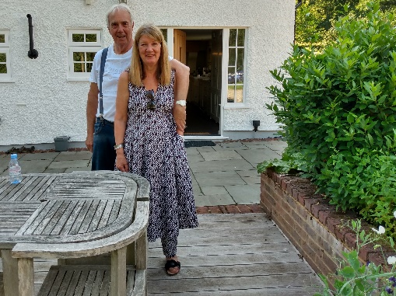
We are so grateful for the wonderful hospitality of Paul and Mair Fry from Rowledge Methodist Church who readily offered their wonderful garden for our event and paddock for parking.
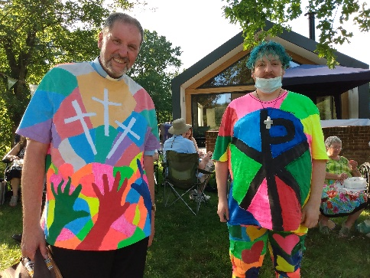
The music band from North Camp led the worship as well there being over 100 people who gathered for a picnic, followed by a very special service. Rev Chris Blake led the service giving thanks to all those who led him to faith, to Joy his wife for her support (they met when Joy was only 14yrs old!) and to God who has been at the centre of his life and calling. Chris had been presented the previous day with a shirt to wear from Michael, one of his church members! The Chair of District, Rev’d David Hinchliffe was the preacher.
This was also a special service for Liam Sheridan who was recognised as a fully accredited Local Preacher after two years of study and hard work. He was presented with a bible and a letter from the Methodist Church. Other Local Preachers who qualified in Lockdown where also celebrated and prayed for.
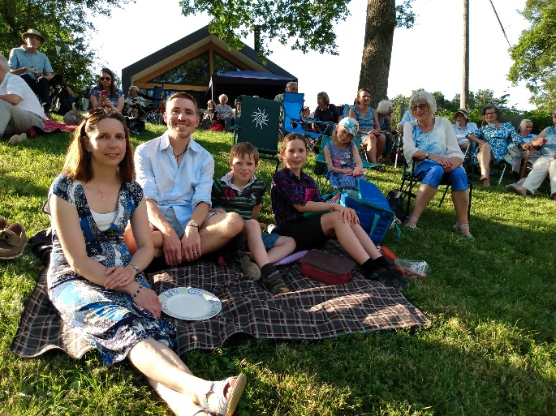
As the sun set on a perfect (but hot!) evening those gathered could be heard singing (yes singing!) that great Wesley hymn, special to Rev Chris:
O thou who camest from above
the fire celestial to impart,
kindle a flame of sacred love
on the mean altar of my heart.

There let it for thy glory burn
with inextinguishable blaze,
and trembling to its source return
in humble prayer and fervent praise.

Jesus, confirm my heart's desire
to work and speak and think for thee;
still let me guard the holy fire
and still stir up the gift in me.
Chris & Joy will soon move to their new home in Poole, Dorset able to enjoy special memories and friends made in the Methodist Circuit.
Cream Tea’s at the Manse – Another Scorcher!
Last Saturday about 30 people gathered in the Manse Garden under the shade provided to enjoy a cream tea wonderfully provided by Angela and Christine. It was so lovely to see everyone, to relax and to catch up with one another.
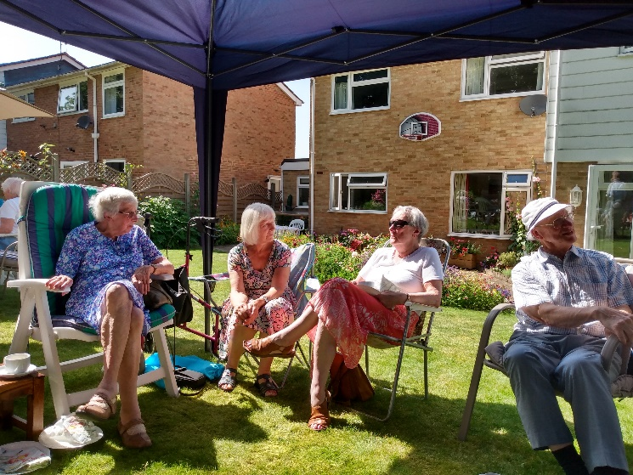
Duke of Edinburgh’s Expedition – Sizzling!
Our Duke of Edinburgh’s Award Bronze participants had been waiting over a year for this! Their two-day expedition across the north Hampshire countryside was about to begin.
On one of the hottest days of the year so far, with the thermometer starting to rise towards thirty degrees, the intrepid group of six set off from Four Marks. Their objective – to visit five churches on a two-day, twenty-five kilometre walk, following paths and tracks.
They did extremely well, and enjoyed their overnight camp near Bramdean Common. Their second day had much less shade, and the group decided, very wisely, to stop for their breaks whenever they came to a copse or belt of trees. Having decided to start at eight in the morning, they managed to avoid the hottest part of the day, and finished near Exton, happy but tired, at 2 o’clock.

Covid Regs News Update…
We are able to sing in church from the 19th July, do not have to book in, and can enjoy refreshments after the service.
The Methodist Church recommends that:
We keep hand sanitiser available
We continue good cleaning & hygiene procedures.
We seek to provide good ventilation in our buildings.
We use our space to allow for some social distancing.
Wearing a face covering is now a matter of personal choice however we are asked to consider wearing them a little longer to protect one another.
We resist handshaking and hugging!

Alton – Tuesday Coffee Morning Returns!
Tuesday July 27th 10-12noon
The Forget Me Not Service
Wednesday 4th August at 2:30pm in All Saints Church led by Rev Rachel Sturt
Church Family News
We are sad to announce the death of Peggy Knight who died this week. The funeral service will be in Alton Methodist on 5th Aug. at 1pm. Peggy has been a faithful servant of the church over many years, we give thanks to God for her.
Worship Services
Alton 25th July – led by Liz George who respectfully requests that on this occasion you wear a mask.
Rowledge and Hale services led by Phil Smith.
The on-line service is led by Liz George co/ www.altonmethodist.org.uk. This will continue during August as a Circuit on-line service.

